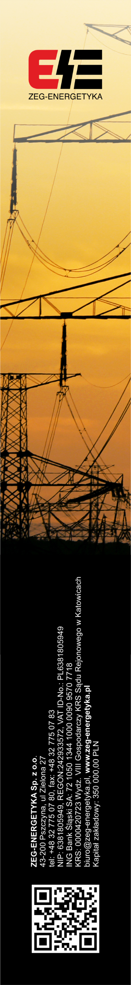
WARRANTY CARD
No 11271 /2023

ZEG-ENERGETYKA Sp. z o.o. guarantees the smooth operation of the device, in accordance with the factory operating instructions.

If the sale was preceded by an Agreement signed by the Buyer and the Seller, the provisions of this Agreement shall apply.
The warranty includes free removal of defects revealed during use, while observing the terms specified in this warranty card

TERMS OF WARRANTY
The Manufacturer warrants subject to the observance of the conditions specified below:
- Installation and operation of the equipment should be in accordance with the factory operating instructions,
- Seal on the enclosure shall not be infringed,
- On the warranty card there cannot be made any amendments or changes.

WARRANTY DOES NOT COVER:
- Damage caused by improper transportation or storage,
- Damage resulting from improper installation or operation,
- Damage due to handling inside the equipment, design changes, modifications
and repairs carried out without the Manufacturer’s consent;
- Cables, cells, measuring electrodes, fuses, light bulbs and other items with limited life span, referred to in the user guide.

INSTRUCTIONS TO BUYER:
- When reporting a complaint, please give reason for complaints (symptoms related to malfunction equipment) and equipment serial number,
- After receiving confirmation of the complaint the device in question should be sent to the address of the manufacturer, together with this warranty card,
- Warranty period is extended by the time of settlement of claims recognized.

Product Name | VOLTAGE-TIME RELAY
Type | RET-325-RMS
Production date | 06.11.2024
Serial Number | 240637, 240638, 240639, 240640
Date of sale
Warranty period | 24 months from the date of sale

....………………………………….......
SEAL AND SIGNATURE OF THE SELLER

